Experiment Title
Inter-Autonomous System Routing Implementation Using Border Gateway Protocol (BGP)
Objectives
This experiment is conducted to study the concept of Autonomous Systems and their interconnection using the Border Gateway Protocol (BGP). The main goal is to configure and observe inter-domain routing between routers belonging to different Autonomous Systems. The experiment also aims to establish BGP neighbor relationships and verify successful data transmission between networks managed under separate AS numbers.
System Requirements
Software Platform:
Cisco Packet Tracer (Version 8.x or later)
Operating System:
Windows 11
Networking Devices:
- Two Cisco 1841 Routers
- One Cisco 2960 Switch
- Two Personal Computers
Cabling Components:
- Copper Straight-Through cables for PC and switch connections
- Serial DCE cable for router-to-router communication
- Copper Cross-over cable where required
Routing Protocol Used:
Border Gateway Protocol (BGP)
Steps and Procedures
Step 1: Placing Devices on Cisco Packet Tracer Workspace
Initially, all required networking devices were placed on the Cisco Packet Tracer workspace. Two routers, one switch, and two PCs were selected and arranged to represent two different Autonomous Systems. Each device was renamed appropriately to maintain clarity during configuration and troubleshooting.

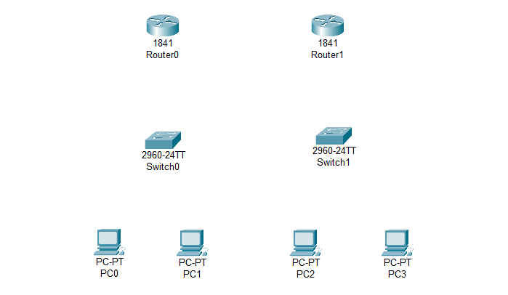
Figure 9.1: Placing all the devices into workstation
Step 2: Connecting wires and Designing the Network Topology
After placing the devices, the two routers were interconnected using a Serial DCE cable to simulate inter-AS communication. Router0 was connected to a switch, and the switch was connected to PC0. Router1 was connected directly to PC1. This setup allowed each router to represent a separate Autonomous System.
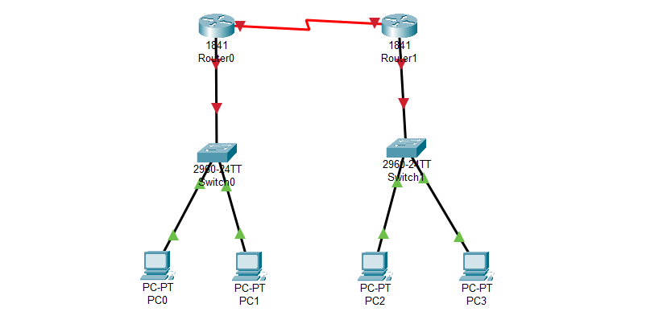
Figure 9.2: Connecting Wires for all devices
Step 3: Assigning IP Addresses to all PCs
IP addresses were manually configured on all PC interfaces. Each PC interface was assigned an IP address belonging to a different network segment to clearly separate the Autonomous Systems. Subnet masks were configured properly to ensure correct network identification.
PC IP Address––––––––––Subnet Mask–––––––Gateway
PC0 192.168.1.2 – 255.255.255.0 – 192.168.1.1
PC1 192.168.1.3 – 255.255.255.0 – 192.168.1.1
PC2 192.168.2.2 – 255.255.255.0 – 192.168.2.1
PC3 192.168.2.3 – 255.255.255.0 – 192.168.2.1

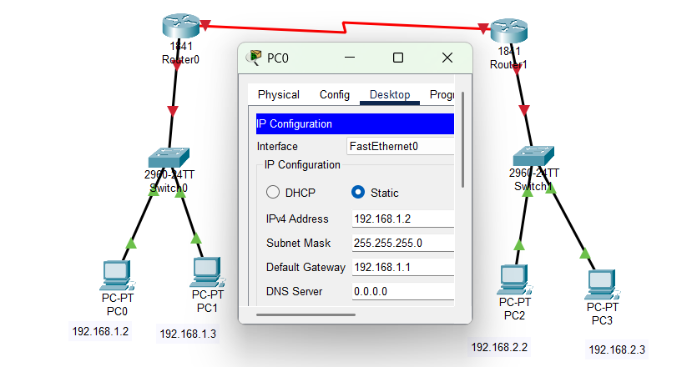
Figure 9.3: Assigning IP Addresses to all PCs
Step 4: Configuring IP Addresses to Routers
IP addresses were manually configured on all router interfaces. Each router interface was assigned an IP address belonging to a different network segment to clearly separate the Autonomous Systems. Subnet masks were configured properly to ensure correct network identification.
For Router0

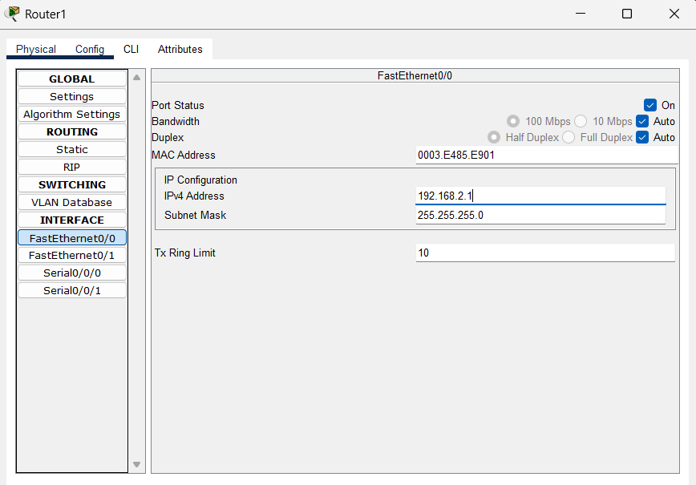
Figure 9.4: Configuring IP address for Router0
For Router1

Figure 9.5: Configuring IP address for Router1
Step 5: Configuring BGP on Routers
BGP was configured on both routers using the command-line interface. Each router was assigned a unique Autonomous System number. Neighbor relationships were established by specifying the remote AS and neighbor IP address. Network statements were added so that each router could advertise its local networks to the neighboring Autonomous System.
For Router0
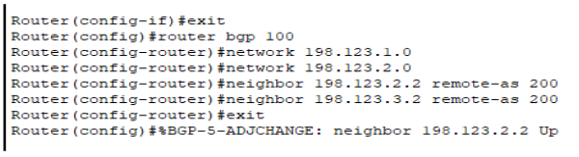
Figure-9.6: Configure BGP to Router0 Using CLI
For Router1
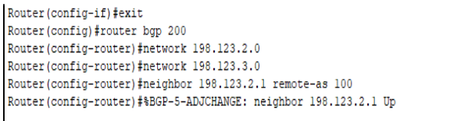
Figure-9.7: Configure BGP to Router1 Using CLI
Step 6: Verifying BGP Operation
To verify correct BGP operation, diagnostic commands were executed on the routers. Commands such as show ip bgp summary, show ip bgp, and show ip route were used to confirm that neighbor relationships were established and that routes were learned through BGP.
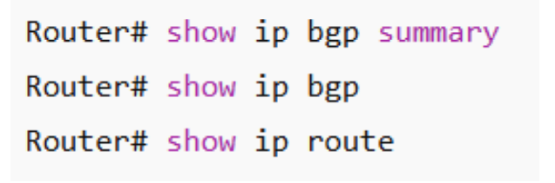
Figure-9.8: Verifying BGP Neighbor Relationship

Step 7: Connectivity Testing
Finally, connectivity between the two networks was tested using the icmp packet transferring. Successful replies confirmed that BGP routing between the Autonomous Systems was functioning as expected.
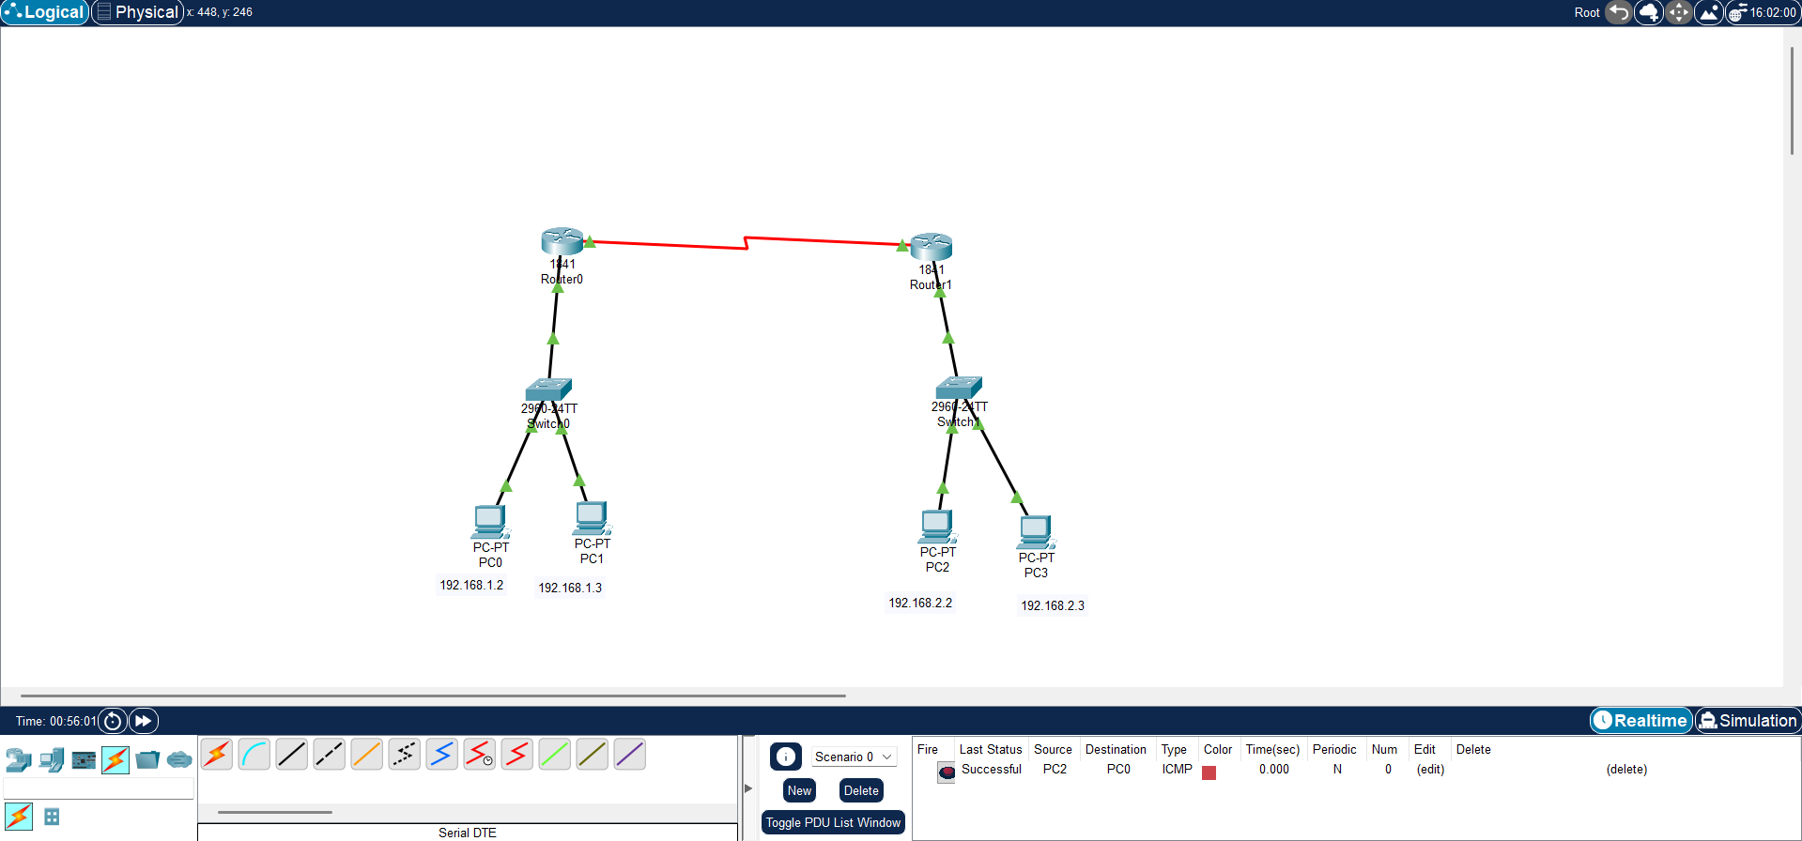
Figure 9.9: Testing The Connectivity using ICMP Packets
Result and Discussion
The experiment successfully demonstrated inter-domain routing using BGP. Routers belonging to different Autonomous Systems were able to form neighbor relationships and exchange routing information. The routing tables were updated dynamically based on BGP advertisements, allowing end devices in separate AS networks to communicate without issues. This experiment highlights the importance of BGP in managing large-scale and independent networks.
Conclusion
In this experiment, the Border Gateway Protocol was implemented to enable routing between two Autonomous Systems. BGP successfully established inter-AS connectivity by exchanging routing information between routers. The successful transmission of packets between devices in different networks confirms the effectiveness of BGP as an inter-domain routing protocol widely used in real-world Internet infrastructure.

